**Lab 5 Exercise**

***Part 1***

Create tables:

* ***States***

Create Table States

(

stateAbbr VARCHAR(2) Primary Key,

stateName VARCHAR(20) Not Null

);

* **City**

Create Table City

(

cityID CHAR(8) Primary Key,

cityName VARCHAR(25) Not Null,

stateAbbr VARCHAR(2) Not Null,

constraint state_FK FOREIGN KEY (stateAbbr) REFERENCES States (stateAbbr)

);

* Airport

Create Table Airport

(

airportID CHAR(3) Primary Key,

airportName VARCHAR(45) Not Null UNIQUE,

cityID CHAR(8) Not Null ,

constraint city_FK FOREIGN KEY (cityID) REFERENCES City (cityID)

);

* FlightRoute

Create Table FlightRoute

(

flightNumber VARCHAR(6) Not Null,

departAirport CHAR(3) Not Null,

arriveAirport CHAR(3) Not Null,

scheduledDepartTime TIME Not Null,

scheduledArrivalTime TIME Not Null,

constraint flightR_PK1 PRIMARY KEY (flightNumber),

constraint airport_FK1 FOREIGN KEY (departAirport) REFERENCES Airport (airportID),

constraint airport_FK2 FOREIGN KEY (arriveAirport) REFERENCES Airport (airportID)

);

* FlightStatus

Create Table FlightStatus

(

statusID CHAR(1) Not Null CHECK (statusID IN('O','D','C')),

description VARCHAR(20) Not Null

CONSTRAINT flightSt_PK PRIMARY KEY (statusID)

);

* AircraftSpecs

Create Table AircraftSpecs

(

aircraftTypeID CHAR(8) PRIMARY KEY,

aircraftVersion VARCHAR(10) Not Null,

cabinNumOfSeats INT,

fuelCapacity INT Not Null,

);

* Airplane

Create Table Airplane

(

airplaneID CHAR(8) Not Null,

aircraftTypeID CHAR(8) Not Null,

purchaseDate DATE Not Null DEFAULT '01/02/2014',

CONSTRAINT airplane_PK PRIMARY KEY (airplaneID),

constraint airplane_FK FOREIGN KEY (aircraftTypeID) REFERENCES AircraftSpecs (aircraftTypeID)

);

* FlightSchedule

Create Table FlightSchedule

(

flightNumber VARCHAR(6) NOT Null,

flightDate DATE Not Null,

statusID CHAR(1) Not Null CHECK (statusID IN('O','D','C')),

airplaneID CHAR(8) Not Null,

delayDepartTime TIME ,

delayArrivalTime TIME ,

constraint flightSc_PK PRIMARY KEY (flightNumber,flightDate),

constraint flightSc_FK1 FOREIGN KEY (statusID) REFERENCES FlightStatus (statusID),

constraint flightSc_FK2 FOREIGN KEY (airplaneID) REFERENCES Airplane (airplaneID)

);

**Insert data**:

* ***States***

Insert into states(stateAbbr, stateName) values ('CA', 'California');

Insert into states(stateAbbr, stateName) values ('DC', 'Washington, D.C.');

Insert into states(stateAbbr, stateName) values ('FL', 'Florida');

Insert into states(stateAbbr, stateName) values ('IL', 'Illinois');

Insert into states(stateAbbr, stateName) values ('MA', 'Massachusetts');

Insert into states(stateAbbr, stateName) values ('NY', 'New York');

Insert into states(stateAbbr, stateName) values ('TX', 'Texas');

* **City**

Insert into City(cityID, cityName, stateAbbr) values('C001','Los Angeles','CA');

Insert into City(cityID, cityName, stateAbbr) values('C002','San Francisco','CA');

Insert into City(cityID, cityName, stateAbbr) values('C003','Washington, D.C.','DC');

Insert into City(cityID, cityName, stateAbbr) values('C004','Miami','FL');

Insert into City(cityID, cityName, stateAbbr) values('C005','Orlando','FL');

Insert into City(cityID, cityName, stateAbbr) values('C006','Chicago','IL');

Insert into City(cityID, cityName, stateAbbr) values('C007','Boston','MA');

Insert into City(cityID, cityName, stateAbbr) values('C008','New York','NY');

Insert into City(cityID, cityName, stateAbbr) values('C009','Syracuse','NY');

* **Airport**

Insert into Airport(airportID, airportName, cityID) values ('BOS','Amonkar','C007');

Insert into Airport(airportID, airportName, cityID) values ('DCA','Ronald Reagan National Airport','C003');

Insert into Airport(airportID, airportName, cityID) values ('IAD','Washington Dulles International Airport','C003');

Insert into Airport(airportID, airportName, cityID) values ('JFK','John F. Kennedy International Airport','C008');

Insert into Airport(airportID, airportName, cityID) values ('LAX','Los Angeles International Airport','C001');

Insert into Airport(airportID, airportName, cityID) values ('LGA','LaGuardia Airport','C008');

Insert into Airport(airportID, airportName, cityID) values ('MCO','Orlando International Airprot','C005');

Insert into Airport(airportID, airportName, cityID) values ('MDW','Chicago Midway International Airport','C006');

Insert into Airport(airportID, airportName, cityID) values ('MIA','Miami International Airport','C004');

Insert into Airport(airportID, airportName, cityID) values ('ORD','Chicago OHare International Airport','C006');

Insert into Airport(airportID, airportName, cityID) values ('SRO','San Francisco International Airport','C002');

Insert into Airport(airportID, airportName, cityID) values ('SYR','Syracuse Hancock International Airport','C009');

* **FlightRoute**

Insert into FlightRoute(flightNumber, departAirport, arriveAirport, scheduledDepartTime, scheduledArrivalTime) values (3310,'SYR','JFK','08:00:00.0000000','09:02:00.0000000');

Insert into FlightRoute(flightNumber, departAirport, arriveAirport, scheduledDepartTime, scheduledArrivalTime) values (3312,'JFK','SYR','12:20:00.0000000','13:30:00.0000000');

Insert into FlightRoute(flightNumber, departAirport, arriveAirport, scheduledDepartTime, scheduledArrivalTime) values (3426,'LAX','ORD','11:15:00.0000000','15:05:00.0000000');

Insert into FlightRoute(flightNumber, departAirport, arriveAirport, scheduledDepartTime, scheduledArrivalTime) values (5063,'BOS','MCO','14:30:00.0000000','18:45:00.0000000');

* **FlightStatus**

Insert into FlightStatus(statusID, description) values ('C','Cancelled');

Insert into FlightStatus(statusID, description) values ('D','Delay');

Insert into FlightStatus(statusID, description) values ('O','On Time');

* **AircraftSpecs**

Insert into AircraftSpecs(aircraftTypeID, aircraftVersion, cabinNumOfSeats, fuelCapacity) values ('AIR1','A321-200',220,7930);

Insert into AircraftSpecs(aircraftTypeID, aircraftVersion, cabinNumOfSeats, fuelCapacity) values ('AIR2','737-600ER',132,6875);

Insert into AircraftSpecs(aircraftTypeID, aircraftVersion, cabinNumOfSeats, fuelCapacity) values ('BOE1','747-400ER',416,63705);

Insert into AircraftSpecs(aircraftTypeID, aircraftVersion, cabinNumOfSeats, fuelCapacity) values ('BOE2','767-300ER',350,23980);

Insert into AircraftSpecs(aircraftTypeID, aircraftVersion, cabinNumOfSeats, fuelCapacity) values ('BOE3','737-600ER',132,6875);

* **Airplane**

Insert into Airplane(airplaneID, aircraftTypeID, purchaseDate) values ('AP098640','AIR2','2013-03-01');

Insert into Airplane(airplaneID, aircraftTypeID, purchaseDate) values ('AP239471','AIR1','1900-01-01');

Insert into Airplane(airplaneID, aircraftTypeID, purchaseDate) values ('AP309814','BOE2','2012-05-22');

Insert into Airplane(airplaneID, aircraftTypeID, purchaseDate) values ('AP629342','BOE1','1900-01-01');

Insert into Airplane(airplaneID, aircraftTypeID, purchaseDate) values ('AP872139','BOE3','1900-01-01');

Insert into Airplane(airplaneID, aircraftTypeID, purchaseDate) values ('AP998911','BOE2','1900-01-01');

* **FlightSchedule**

Insert into FlightSchedule(flightNumber, flightDate, statusID, airplaneID) values(3310,'2014-02-10','O','AP629342');

Insert into FlightSchedule(flightNumber, flightDate, statusID, airplaneID) values(3310,'2014-02-11','O','AP629342');

Insert into FlightSchedule(flightNumber, flightDate, statusID, airplaneID) values(3312,'2014-02-10','O','AP872139');

Insert into FlightSchedule(flightNumber, flightDate, statusID, airplaneID) values(3426,'2014-02-12','O','AP239471');

Insert into FlightSchedule(flightNumber, flightDate, statusID, airplaneID) values(5063,'2014-02-13','D','AP309814');

**Select data:**

* ***States***

select * from states;

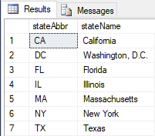

* **City**

select * from City;

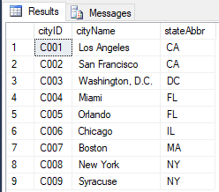

* **FlightRoute**

select * from FlightRoute;

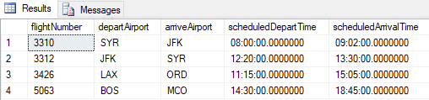

* **Airport**

select * from Airport;

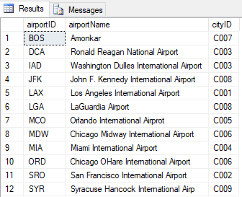

* **FlightStatus**

select * from FlightStatus;

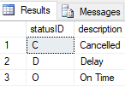

* **AircraftSpecs**

select * from AircraftSpecs;

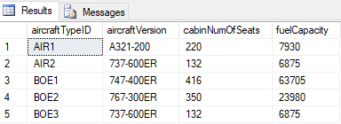

* **Airplane**

select * from Airplane;

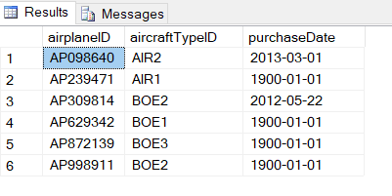

* **FlightSchedule**

Select * from FlightSchedule;

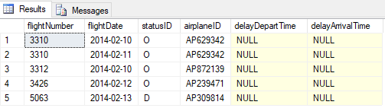

***Part 2***

**Using the above tables and data, write queries to answer the following questions**

**QUESTIONS**: Table Queries

1. Find all aircrafts whose fuel capacity is less than 63705. Show aircraft id, cabin number of seats and fuel capacity.

**Query**:

select aircraftTypeID, cabinNumOfSeats, fuelCapacity

from AircraftSpecs

where fuelCapacity < 63705

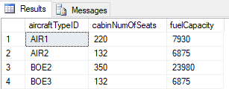

1. Find all airplanes which were on time or delayed. Show only airplane ID, flight date and statusID.

**Query:**

select airplaneID, flightDate, statusID

from FlightSchedule

where statusID IN('O','D')

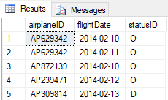

1. Find all the airplanes that have been purchased before the year 2013-02-10. Show airplane id and the purchase Date.

**Query:**

select airplaneID, purchaseDate

from Airplane

where purchaseDate < '2013-02-10';

